**OUTPUT OF TASK : 1**

LOGIN FORM:

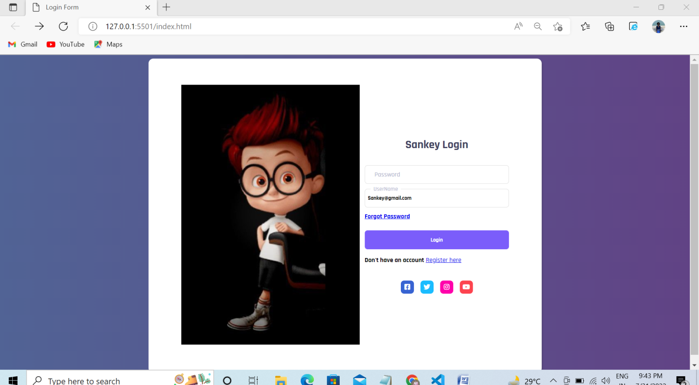

RESPONSIVE PAGE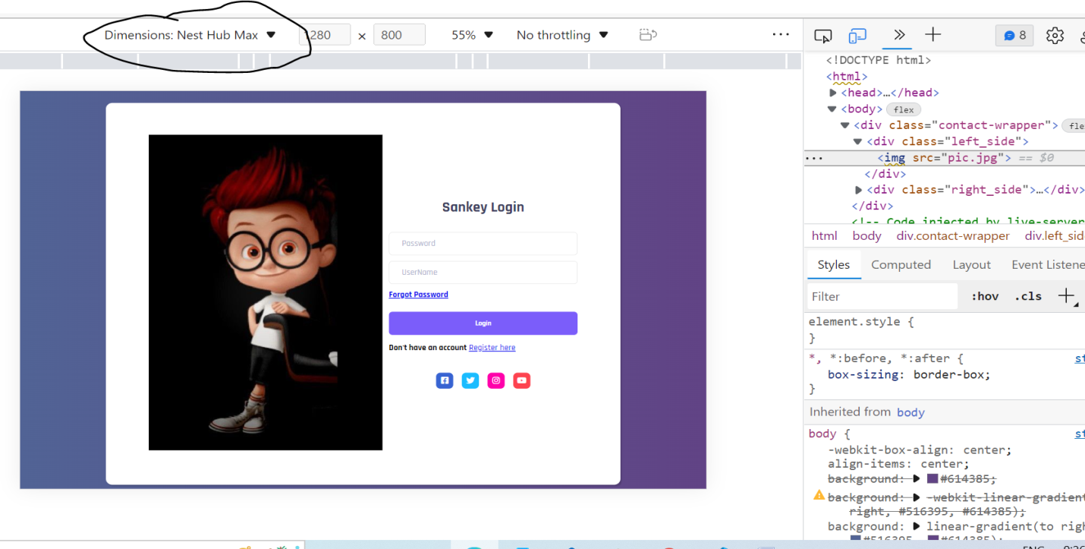

RESPONSIVE PAGE

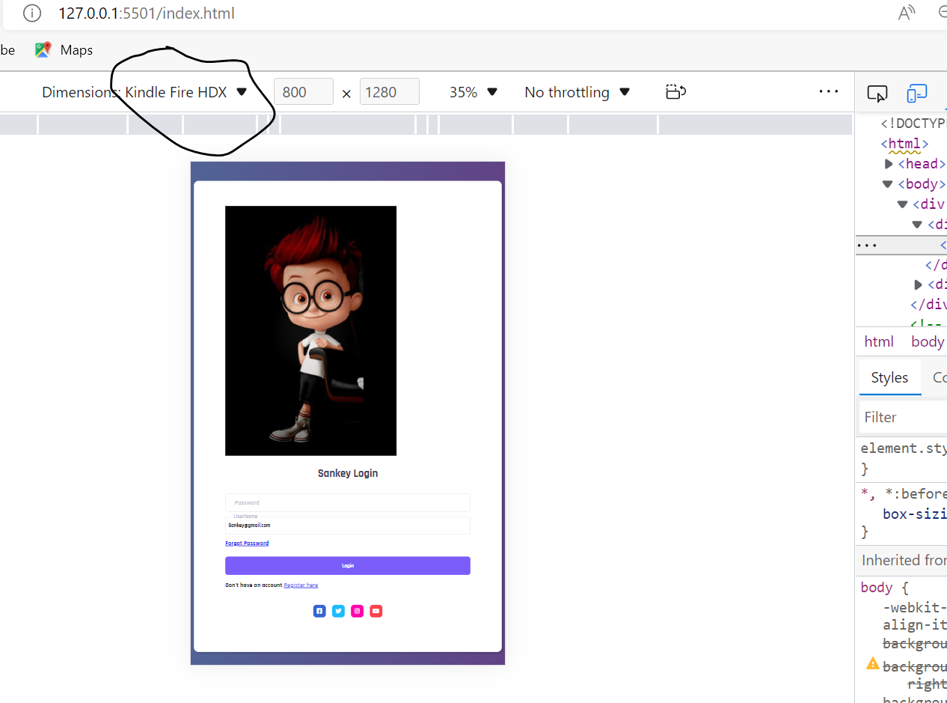

**OUTPUT OF TASK : 2**

**Login (UserName & Password)**

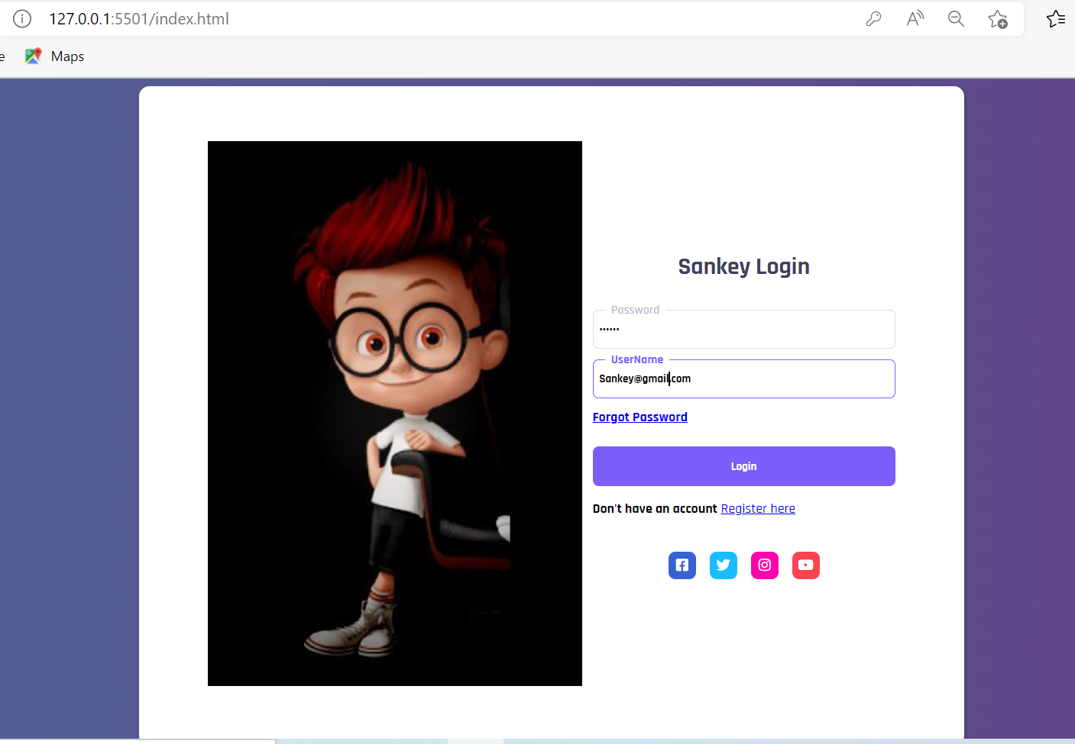

**AFTER CLICK ON LOGIN BUTTON(NEW PAGE IS LOADED)**

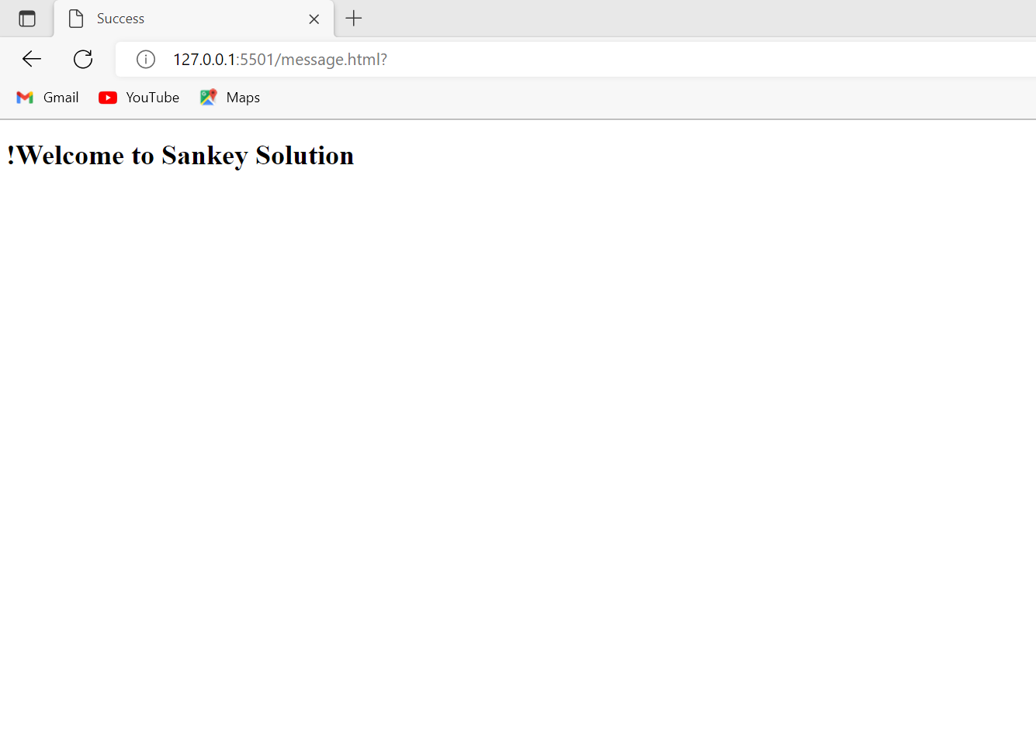

**OUTPUT OF TASK : 3**

**FETCHING DATA:**

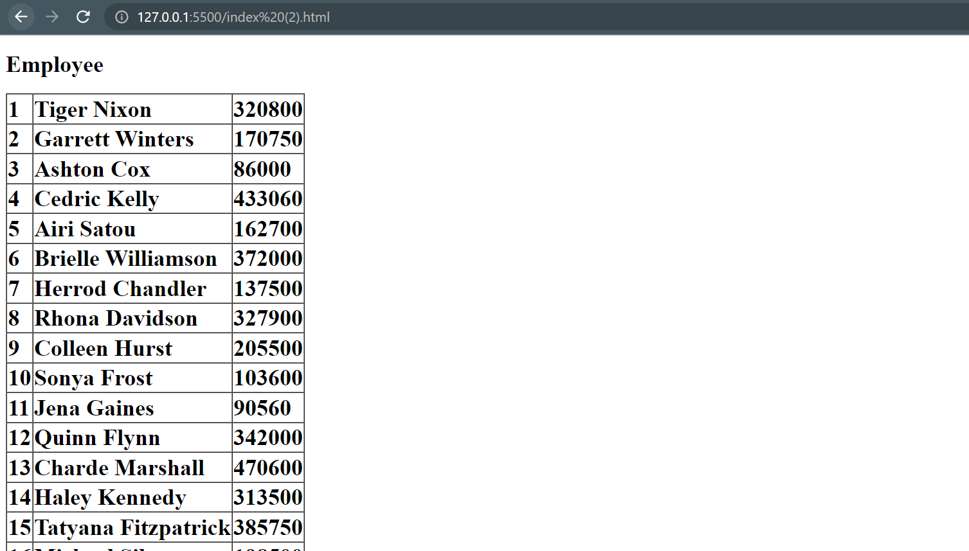

**CONSOLE.LOG:**

